Woodston Primary School Safeguarding & Child Protection Policy
This policy is informed by Keeping Children Safe in Education (KCSiE) September 2025
and includes statutory guidance which academies must have regard to.

For ease of use the updates have been written in red.

Document Control
Author | WPS Safeguarding Lead
Version Number: | 1
Applicable To: | WPS
Approved by
Final Approval by | LGC
Approved | September 2025
Review Cycle: | Annual
Date of Next Review: | September 2026
To be published on website (yes/no) | yes
Related Policies: | Anti-bullying policy  Attendance policy (including Children who are absent from Education)  Behaviour policy  Complaints policy  Equality policy  First Aid policy  Health and Safety policy  Intimate Care policy  Lone Working policy  Online Safety and Acceptable Use policy (includes the use of mobile phones and other smart devices)  Safer Recruitment policy  Staff Code of Conduct/Safer Working Practice  Staff Discipline and Grievance procedures  Supporting Pupils with Medical Conditions policy  Whistleblowing policy
Related Documents: | Keeping Children Safe in Education (KCSiE): Sept 2025  Guidance for Safer Working Practice for those working with children and young people in education settings (May 2019)  Guidance from Cambridgeshire Authority: Record Keeping Guidance to take account of GDPR: Sept 2018  Record Keeping Guidance from Cambridgeshire Authority (GDPR): Sept 2018  Working Together to Safeguard Children: Dec 2023  Disqualification under the Childcare Act 2006: statutory guidance for local authorities, maintained schools, academies and free schools (July 2018)  Information sharing: Advice for practitioners providing safeguarding services to children, young people, parents and carers: May 2024  Multi-agency statutory guidance on female genital mutilation: April 2016  Advice for practitioners: March 2015  The Prevent Duty, an introduction for those with safeguarding responsibilities: June 2023  Prevent Guidance for England and Wales: March 2024  Education Child Protection Record Keeping Guidance  Guidance for Safer Working Practice for Adults who work with Children and Young People in Education Settings: Oct 2015  What to do if you’re worried a child is being abused: Advice for practitioners” Mar 2015  Sexting in schools and colleges: Responding to incidents and safeguarding young people” published by the UK Council for Child Internet Safety (UKCCIS) – (September 2016)  Sharing nudes and semi-nudes: advice for education settings working with children and young people (UKCIS, March 2024)  The Equality Act 2021update  When to call the Police guidance  Responding to Prejudice Related Incidents Policy  Relationships Education, Relationships and Sex Education (RSE) & Health Education, DfE, 2021  Keeping children safe during community activities, after-school clubs, and tuition: non-statutory guidance for providers running out-of-school settings May 2025  Meeting digital and technology standards in schools and colleges, Filtering and monitoring standards for schools and colleges March 2025  Searching, Screening and Confiscation Advice for Schools, DFE July 2022

Contents page
REF | DESCRIPTION | PAGE
1 | Introduction | 4
2 | Main Elements of the Policy | 4
2.1 | Prevention | 5-7
2.2 | Procedures | 7-12
3 | Supporting children | 12-18
4 | Preventing unsuitable people from working with children | 17-19
5 | Other related policies and guidance | 19-20
6 | Academy Council responsibilities | 20
Appendix A | Categories of Abuse, Neglect & Exploitation | 21-22
Appendix B | Table of changes from KCSIE September 2024 version | 23-24
Appendix C | Useful Contacts: Local Authority Safeguarding Boards / Children’s Partnerships | 25
Academy Specific Information | Orton Wistow Primary School safeguarding team details and roles | 26

1 Introduction

WPS fully recognises the responsibility it has under section 175 the Education Act 2002, the Non-Maintained Special Schools (England) Regulations 2015, and the Education and Training (Welfare of Children) Act 2021, to have arrangements in place to safeguard and promote the welfare of children.

Safeguarding and promoting the welfare of children is everyone’s responsibility. ‘Children’ includes everyone under the age of 18.

This responsibility is more fully explained in the statutory guidance for schools and colleges ‘Keeping Children Safe in Education’ (September 2025). All staff must be made aware of their duties and responsibilities under Part One of this document, which are set out below.

Staff should read the above document together with ‘Annex B’ of ‘Keeping Children Safe in Education’, 2025 and ‘What to do if you’re worried a child is being abused: Advice for practitioners’ (March 2015) if they are working directly with children. For those staff who do not work directly with children Annex A can be issued instead but this is a matter for the school/college to decide.

Through their day-to-day contact with pupils and direct work with families all staff at WPS have a responsibility to:

- Identify concerns early to prevent them from escalating
- Provide a safe environment in which children can learn
- Identify children who may benefit from early help
- Know what to do if a child tells them he/she is being abused, neglected or exploited
- Follow the referral process if they have a concern

This policy sets out how the LGC discharges its statutory responsibilities relating to safeguarding and promoting the welfare of children who are pupils at the academy. Our policy applies to all staff, paid and unpaid, working in the academy including governors. Teaching assistants, mid-day supervisors, office staff as well as teachers can be the first point of disclosure for a child. Concerned parents/carers may also contact the academy and its Academy Councilors.

It is consistent with the Safeguarding Children Partnership Board procedures.

This policy reflects the Peterborough Safeguarding Children Boards, Child Protection Procedures and “Keeping Children Safe in Education” September 2025.

2 Main Elements of the Policy

There are four main elements to our policy:

PREVENTION through the teaching and pastoral support offered to pupils and the creation and maintenance of a whole academy protective ethos
PROCEDURES for identifying and referring cases, or suspected cases, of abuse or exploitation. The definitions of the four categories of abuse are detailed in Appendix A

SUPPORTING CHILDREN particularly those who may have been abused or witnessed violence towards others.

PREVENTING UNSUITABLE PEOPLE WORKING WITH CHILDREN processes are followed to ensure that those who are unsuitable to work with children are not employed.

This Policy is available on request and on the WPS website.

2.1 PREVENTION

We recognise that high self-esteem, confidence, supportive friends and good lines of communication with a trusted adult help to protect children.

The academy will therefore:

    - Establish and maintain an environment where children feel safe in both the real and the virtual world, including in a digital context and are encouraged to talk and are listened to

    - Ensure children know that there are adults in the academy whom they can approach if they are worried or in difficulty and their concerns will be taken seriously and acted upon as appropriate

    - Tailor our curriculum to be age and stage of development appropriate so that it meets the specific needs and vulnerabilities of individual children, including children who are victims of abuse, and children with special educational needs or disabilities.

    - Incorporate into the curriculum, activities and opportunities that enable children to develop their understanding of stereotyping, prejudice and equality.

    - Ensure that all school staff challenge instances of prejudice related behaviour, including but not limited to, instances of sexism, misogyny/misandry, homophobia, biphobic and sexual violence/harassment. Any prejudice related incidents will be responded to in accordance with our ‘Responding to Prejudice-Related Incidents Policy’.

Incorporate into the curriculum, activities and opportunities which equip children with the skills they need to stay safer from abuse and exploitation in all contexts, based on the current 2019 RSE guidance.

During the course of the year, schools will be moving towards delivering the following content from the 2025 RSE guidance:
- That families are important for children growing up safe and happy because they can provide love, security and stability.
- How to recognise if family relationships are making them feel unhappy or unsafe and how to seek help or advice from others if needed.
- That healthy friendships are positive and welcoming towards others, and do not make others feel lonely or excluded. Pupils should learn skills for developing caring, kind friendships.
- How to recognise when a friendship is making them feel unhappy or uncomfortable, and how to get support when needed.
- How to seek help when needed, including when they are concerned about violence, harm, or when they are unsure who to trust.
- How to critically evaluate their online relationships and sources of information, including awareness of the risks associated with people they have never met. For example, that people sometimes behave differently online, including pretending to be someone else, or pretending to be a child, and that this can lead to dangerous situations. How to recognise harmful content or harmful contact, and how to report this.
- That the internet contains a lot of content that can be inappropriate and upsetting for children, and where to go for advice and support when they feel worried or concerned about something they have seen or engaged with online.
- That each person’s body belongs to them, and the differences between appropriate and inappropriate or unsafe contact, including physical contact.
- How to respond safely and appropriately to adults they may encounter (in all contexts, including online) whom they do not know.
- How to report abuse, concerns about something seen online or experienced in real life, or feelings of being unsafe or feeling bad about any adult and the vocabulary and confidence needed to do so. How to report concerns or abuse, and the vocabulary and confidence needed to do so.
- How to ask for advice or help for themselves or others, and to keep trying until they are heard. Where to get advice e.g. family, school and/or other sources.

(Relationships Education, Relationships and Sex Education (RSE) & Health Education, DfE, 2019)
(Relationships Education, Relationships and Sex Education (RSE) & Health Education, DfE, 2025 – to be fully implemented by 2026)

    - Include in the curriculum material which will help children develop realistic attitudes to the responsibilities of adult life, particularly with regard to childcare and parenting skills

    - We use and refer to PSHE Association materials for Personal Development and Personal Safety Units in our primary and special academies.

    - Some of our primary Academies use the Safer Spaces Toolkit. This was developed by the Cambridgeshire PSHE Service which supports schools with listening to pupil voice, building awareness and engaging in reflection as part of a whole school approach to preventing sexist attitudes and behaviours which cause others to feel unsafe.

2.2 PROCEDURES: Academy specific contacts are detailed at the end of this Policy

2.2.1 We will follow:

The procedures set out in the relevant Safeguarding Board / Safeguarding Children’s Partnership for the Local Authority for each Academy. Details can be found in Appendix C

2.2.2 The LGC will appoint a senior member of staff, from the leadership team, to the role of Designated Safeguarding Lead (DSL). The DSL will take lead responsibility for safeguarding and child protection.

    - The DSL should have the appropriate status and authority within the academy to carry out the duties of the post. They should be given the time, funding, training, resources and support to provide advice and support to other staff on child welfare and child protection matters (See ‘Keeping Children Safe in Education, 2025, Annex C).

    - The activities of the DSL can be delegated to appropriately-trained deputies (Deputy Designated Safeguarding Lead; DDSL).

    - The lead responsibility for safeguarding and child protection remains with the DSL and cannot be delegated.

    - The role of DSL and DDSL is explicit in the post holder’s job description

    - The DSL and DDSL should undergo the two-day training provided by the Education Child Protection Service. This training should be updated at least every two years.

    - In addition to the formal training set out above the DSL and DDSL should refresh their knowledge and skills e.g. via updates, meetings or additional training at least annually.

    - Academy Councils should also ensure that every member of staff, paid and unpaid, and the Academy Council knows who the Designated Personnel are and the procedures for passing on concerns from the point of induction. In most of the academies this involves the use of reporting concerns via My Concern.

    - Keeping Children Safe in Education states “During term time the designated safeguarding lead (Or a deputy) should always be available (during academy hours) for staff to discuss any safeguarding concerns. Whilst generally speaking the designated safeguarding lead (or deputy) would be expected to be available in person, it is a matter for an individual academy to define what “available” means”. In the rare event that neither the DSL or DDSL are available; Keeping Children Safe in Education 2025, Annex C page 171, states that the academy must organise a contingency plan or cover arrangements in the event of this unavailability.

    - Liaise with the three safeguarding partners (Local Authority, Integrated Care Board and police) as appropriate and work with other agencies in line with Working Together to Safeguard Children, 2018

    - The LGC should ensure that DSLs and DDSL take advice from a child protection specialist when managing complex cases. The Designated Personnel have access to both the Advice Line run by the Education Child Protection Service and Children’s Social Care. The Emergency Duty Team (out of hours) is also available.

    - The LGC should nominate Governor / Councilor for safeguarding and child protection who has undertaken appropriate training.

    - The LGC should ensure every member of staff and every Councilor knows:

- The name of the designated safeguarding leads, and deputies, and their role
- How to identify the signs of abuse, neglect and exploitation, understanding that children can be at risk of harm inside and outside of the school, inside and outside of home, and online.
- That children may not feel ready or know how to tell someone that they are being abused, exploited or neglected and/or they may not recognise their experiences as harmful
- How to pass on and record concerns about a pupil
- That they have an individual responsibility to be alert to the signs and indicators of abuse and exploitation and; for referring safeguarding concerns to the DSL/ DDSL
- What is meant by, and the importance of, showing professional curiosity
- That they have a responsibility to provide a safe environment in which children can learn
- Where to find the Multi-Agency Procedures on the Safeguarding Children’s Partnership Board website
- Their role in the early help / targeted support process;
- The process for making referrals to children’s social care.
- The safeguarding response to children who are absent from education, particularly on repeat occasions and/or prolonged periods.
- The role of filtering and monitoring and the process for reporting issues

2.2.14 Ensure all staff receive appropriate safeguarding and child protection training (including online safety which, amongst other things, includes an understanding of the expectations, applicable roles and responsibilities in relation to filtering and monitoring, at induction. The training should be regularly updated, as required, and at least annually, to continue to provide them with relevant skills and knowledge to safeguard children effectively.

2.2.15 The LGC should ensure that all staff members undergo safeguarding and child protection training at induction. The training should be regularly updated. In addition, all staff members should receive regular safeguarding and child protection updates as required but at least annually.

    - The LGC should ensure that all staff, paid and unpaid, recognise their duty and feel able to raise concerns about poor or unsafe practice in regard to children and that such concerns are addressed sensitively and effectively in a timely manner in accordance with agreed whistle-blowing policies, including low level concerns and allegations against staff.

    - The LGC should ensure that parents are informed of the responsibility placed on the academy and staff in relation to child protection by setting out these duties on the academy website.

    - The LGC should ensure that this policy is available publicly via the academy website or by other means.

    - Promote educational outcomes by sharing information about the welfare, safeguarding and child protection issues that children, including those who have / had a social worker, are experiencing/have experienced with teachers and school and leadership staff.

    - Where pupils are educated off site or in alternative provision, the academy will obtain written information from the alternative provider that appropriate safeguarding checks have been carried out on individuals working at their establishment.

    - Where pupils are educated off site or in alternative provision, the academy and the provider will have clear procedures about managing safeguarding concerns between the two agencies. Where a school places a pupil with an alternative provision provider, it continues to be responsible for the safeguarding of that pupil and should be satisfied that the placement meets the pupil’s needs.

    - The academy should be able to demonstrate the robustness of these procedures on request and during audits regarding alternative or off-site provision.

2.3 Multi-Agency Working

The academy will:

2.3.1 Work to develop effective links with relevant services to promote the safety and welfare of all pupils

2.3.2 Co-operate as required, in line with Working Together to Safeguard Children July 2018, with key agencies in their enquiries regarding child protection matters including attendance and providing written reports at child protection conferences and core groups

2.3.3 Notify the relevant Social Care Unit immediately if:

- It should have to suspend or exclude a pupil who is subject to a Child Protection Plan (whether fixed term or permanently);
- There is an unexplained absence of a pupil who is subject to a Child Protection Plan
- There is any change in circumstances to a pupil who is subject to a Child Protection Plan

2.3.4 When a pupil who is subject to a Child Protection Plan leaves, information will be transferred to the new school immediately. The Child Protection Chair and Social Work Unit will also be informed.

2.4 Record Keeping

The academy will:

2.4.1 Keep clear, detailed, accurate, written records of concerns about children (noting the date, event and action taken), even where there is no need to refer the matter to Children’s Social Care immediately.

2.4.2 All concerns, discussions and decisions made, and the reasons for those decisions, should be recorded in writing. It is good practice to keep concerns and referrals in a separate safeguarding file for each child; this can be in electronic form through MyConcern. In addition, appropriate secure storage arrangements are in place for any historic hardcopy safeguarding files.

2.4.3 Records should include:
- A clear and comprehensive summary of the concern;
- The child’s wishes and feelings
- Details of how the concern was followed up and resolved;
- A note of any action taken, decisions reached and the outcome;
- A record of any discussion / communication with parents, other agencies etc

2.4.4 Ensure all relevant safeguarding records are sent to the receiving school or establishment when a pupil moves schools in accordance with ‘Keeping Children Safe in Education’ (September 2025, page 174) and the Education Safeguarding Team’s Guidance on Keeping and Managing Child Safeguarding Records. The DSL will consider whether it would be appropriate to share information with the new school/college in advance of a child leaving.

2.4.5 Make parents aware that such records exist except where to do so would place the child at risk of harm.

2.4.6 Ensure all actions and decisions will be led by what is considered to be in the best interests of the child and rationales are included for all discussions and decisions made.

2.5 Confidentiality and Information Sharing

2.5.1 Information about children and their families is defined as ‘special category data’, i.e. information that identifies a living individual. Collection, storage and sharing of personal data is governed by the UK General Data Protection Regulations (UK GDPR) and the Data Protection Act 2018.

The academy will:

2.5.2 Ensure staff and volunteers adhere to confidentiality protocols and that information is shared appropriately.
2.5.3 Ensure staff are aware that they have a professional responsibility to share information with other agencies in order to safeguard children, (as set out in ‘Information sharing; Advice for practitioners providing safeguarding services to children, young people, parents and carers,’ DfE, May 2024).

2.5.4 Ensure that if a member of staff receives a Subject Access Request (under the Data Protection Act 2018) from a pupil or parent they will refer the request to the DSL or Headteacher.

2.5.5 Ensure staff are clear with children that they cannot promise to keep secrets.

The Designated Safeguarding Lead/Deputies will:

2.5.6 Disclose information about a pupil to other members of staff on a ‘need to know’ basis, considering what is necessary, proportionate, and relevant. Parental consent may be required.

2.5.7 Aim to gain consent to share information and be mindful of situations where to do so would place a child at increased risk of harm. Information may be shared without consent where to do so might place the child or another person at immediate risk of harm or prejudice the prevention or detection of crime.

2.5.8 Record when decisions are made to share or withhold information, who information has been shared with and why. (See ‘Working Together to Safeguard Children,’ 2023)

2.5.9 In cases where the ‘serious harm test’ is met, schools must withhold providing the data in compliance with schools’ obligations under the Data Protection Act 2018 and the UK GDPR. Where in doubt schools should seek independent legal advice.
2.5.10 Seek advice about confidentiality from outside agencies if required. (See ‘Information sharing; Advice for practitioners providing safeguarding services to children, young people, parents and carers,’ DfE, May 2024).

2.6 Communication with Parents/Carers

The academy will:

    - Ensure that parents/carers are informed of the responsibility placed on the academy and staff in relation to child protection by setting out its duties in the academy prospectus/website.

    - Undertake appropriate discussion with parents/carers prior to involvement of another agency unless the circumstances preclude this action.

    - Record what discussions have taken place with parents or if a decision has been made not to discuss it with parents, for example if the school/college believes that notifying parents could place the child or another person at immediate risk of harm or prejudice the prevention or detection of crime, the rationale must be recorded. Records may subsequently be disclosable to relevant partner agencies if a Child in Need or Child Protection Enquiry is undertaken.

2.7 Child on Child Abuse

All staff should be aware that children can abuse other children (often referred to as child-on-child abuse), and that it can happen both inside and outside of school or college and online. By definition, it applies to abuse by one child of another child – regardless of the age, of stage of development, or any age differential between them.

We recognise that child on child abuse can manifest itself in many ways. This can include but is not limited to: bullying (including cyberbullying, prejudice-based and discriminatory bullying); abuse within intimate personal relationships; between children; physical abuse such as hitting, kicking, shaking, biting, hair pulling, or otherwise causing physical harm; harmful sexual behaviour, sexual violence and sexual harassment; child criminal exploitation; consensual and non-consensual sharing of nudes and semi-nudes images and/or videos; causing someone to engage in sexual activity without consent, such as forcing someone to strip, touch themselves sexually, or to engage in sexual activity with a third party; upskirting part of the Voyeurism (Offences) Act, April 2019); hate incidents and hate crime; racism and initiation/ hazing type violence and rituals

Addressing inappropriate behaviour (even if it appears to be relatively innocuous) can be an important intervention that helps prevent problematic, abusive and/or violent behaviour in the future.

All forms of child-on-child abuse are unacceptable and will be taken seriously.

The academy will therefore:

    - Create a whole school protective ethos in which child on child abuse, including sexual violence and sexual harassment will not be tolerated.

    - Provide training for staff about recognising and responding to child-on-child abuse, including raising awareness of the gendered nature of peer abuse, with girls more likely to be victims and boys perpetrators.

    - Ensure that staff do not dismiss instances of child-on-child abuse, including sexual violence and sexual harassment as an inevitable part of growing up or ‘banter’.

    - Include within the curriculum, information and materials that support children in keeping themselves safe from abuse, including abuse from their peers and online.

    - Provide high quality Relationship and Sex Education (RSE), and / or enrichment programmes, including teaching about consent. Additional guidance on sexting can be found in ‘Sexting’ in schools: advice and support around self-generated images - What to do and how to handle it, published by CEOP.

    - Ensure that staff members follow the procedures outlined in this policy when they become aware of child-on-child abuse, referring any concerns of child-on-child abuse to the Designated Safeguarding Lead (or deputy) in line with safeguarding reporting procedures.

    - Staff should be aware that some groups are potentially more at risk. Evidence shows girls, children with special educational needs and disabilities (SEND) and LGBT children are at greater risk. School will ensure that these children have a trusted adult in school to talk to.

    - Recognise the risk of intra familial harms and provide support to siblings following incidents when necessary.

    - The Designated Safeguarding Lead will refer to the Safeguarding Children Partnership Board’s Child Sexual Abuse Assessment Tool if there is a concern that a young person may be displaying sexually harmful behaviours, may have experienced sexual violence or sexual harassment or other forms of sexual abuse.

2.8 Dealing with Sexual Violence and Sexual Harassment between children

Sexual violence and sexual harassment can occur between two children of any age and sex from primary to secondary stage and into colleges. It can occur also through a group of children sexually assaulting or sexually harassing a single child or group of children. Sexual violence and sexual harassment exist on a continuum and may overlap; they can occur online and face-to-face (both physically and verbally) and are never acceptable.

Children who are victims of sexual violence and sexual harassment will likely find the experience stressful and distressing. This will, in all likelihood, adversely affect their educational attainment and will be exacerbated if the alleged perpetrator(s) attends the same school or college. Sexual violence and sexual harassment exist on a continuum and may overlap; they can occur online and face to face (both physically and verbally) and are never acceptable.

The academy will:

    - Be clear that there is a zero-tolerance approach to sexual violence and sexual harassment, that it is never acceptable and will not be tolerated.

    - Provide training for staff on how to manage a report of sexual violence or sexual harassment.

    - Make decisions on a case-by-case basis.

    - Reassure victims that they are being taken seriously, offer appropriate support and take the wishes of the victim into account when decision making.

    - Implement measures to keep the victim, alleged perpetrator and if necessary other children and staff members, safe. Record any risk assessments and keep them under review.

    - Give consideration to the welfare of both the victim(s) and perpetrator(s) in these situations.

    - Liaise closely with external agencies, including police and social care, when required.

    - Refer to ‘Keeping Children Safe in Education - Part Five’, 2025, ‘Sexual violence and sexual harassment between children in schools and colleges,’ (DfE, September 2021) for full details of procedures to be followed in such cases. Also see ‘Sharing nudes and semi-nudes: advice for education settings working with children and young people’ (UKCIS, March 2024)

3.0 SUPPORTING CHILDREN

We recognise that any child may be subject to abuse and neglect, and that mental health problems can, in some cases, be an indicator that a child has suffered or is at risk of suffering abuse, neglect or exploitation and as such the Academy will support all children by:

3.1 Providing curricular opportunities to encourage self-esteem and self-motivation

3.2 Creating an ethos that actively promotes a positive, supportive and safe environment and values the whole community.

3.3 Applying the academy's behaviour policy effectively to support vulnerable pupils in the academy. All staff will agree on a consistent approach, which focuses on the behaviour of the child but does not damage the pupil's sense of self-worth. The academy will ensure that the pupil knows that some behaviour is unacceptable, but s/he is valued and not to be blamed for any abuse which has occurred.

3.4 Liaising with the senior mental health lead where safeguarding concerns are linked to mental health in school/college for advice on case management.

3.5 Liaising with other agencies which support the pupil such as Social Care, Child and Adolescent Mental Health Services, Sexual Behaviour Services, Addiction Support, Locality or Early Help (Targeted Support) Teams.

3.6 Promoting supportive engagement with parents and/or carers in safeguarding and promoting the welfare of children, including where families may be facing challenging circumstances

3.7 Recognising that whilst any child may benefit from early help, staff are encouraged to consider the wider environmental factors present in a child’s life which could pose a threat to their welfare or safety, (Risks outside the home). Staff are required to be particularly alert to the potential need for early help for children in particular circumstances. Please see page 10 of Keeping Children Safe in Education, 2025 for the complete list. The list includes:

3.1 Children with Disabilities, Certain Health Conditions, Additional Needs or Special Educational Needs

3.1.1 Our SEND policy is set out in a separate document. Published in 2009, ‘Safeguarding disabled children: practice guidance’ is an important part of the guidance for everyone involved in safeguarding. We recognise that Children with special educational needs and/or disabilities are at higher risk of harm than most children yet keeping them safe can be more of a challenge. Academy staff who deal with children with profound and multiple disabilities, cerebral palsy, sensory impairment and/or emotional and behaviour problems, especially those with communication difficulties are particularly sensitive to signs of abuse. Where children have significant communication difficulties staff will ensure that opportunities for communication, in any form, are given by skilled staff.

3.1.2 We recognise that, statistically, children with additional needs, special educational needs, emotional and behavioural difficulties and disabilities are more vulnerable to abuse and can face additional safeguarding challenges both online and offline. Academy staff who deal with children with complex and multiple disabilities and/or emotional and behavioural problems should be particularly sensitive to indicators of abuse, neglect and exploitation.

3.1.3 The academy has pupils with emotional and behavioural difficulties and/or challenging behaviours. The academy will support staff to decide appropriate strategies that will reduce anxiety for the individual child and raise self–esteem as part of an overall behaviour support plan agreed with parents/carers.

3.1.4 As part of the PSHE curriculum staff will teach children personal safety skills commensurate with their age, ability and needs. Children will be taught personal safety skills such as how to recognise if they are feeling unsafe including within family relationships and friendships; how to ask for help; the difference between safe and unsafe secrets; the difference between safe and unsafe physical contact; and how to recognise and manage risk including in a digital context and online. The content of lessons will be shared with parents/carers so that these skills can be supported at home.

3.1.5 The academy has pupils who may have communication difficulties, and we are aware that they are vulnerable to abuse because they are unable to express themselves to others. Instead, such children will often exhibit changes in behaviours or signs and indicators of abuse recognised by staff with a good knowledge of the child.

3.1.6 Under the Equality Act, there is also a duty to make reasonable adjustments for disabled children and young people. Where necessary, the academy will provide additional training to staff in the use of Makaton, PECS or other communication systems. Supervision by senior managers will be vigilant to create a protective ethos around the child.

3.1.7 We promote high standards of practice, including ensuring that disabled children know how to raise concerns, and have access to a range of adults with whom they can communicate.

3.1.8 For Special Schools within Meridian Trust all pupils have an Education, Health and Care Plan and multi–agency planning and involvement to support integrated care.

  - Young Carers

    - The academy recognises that children who are living in a home environment which requires them to act as a young carer for a family member with an illness or disability, mental health condition or an addiction can increase their vulnerability and that they may need additional support and protection.

    - The academy will seek to identify young carers; offer additional support internally; signpost to external agencies; be particularly vigilant to the welfare of young carers and follow the procedures outlined in this policy, referring to Early Help or Social Care as required if concerns arise.

3.3 Children at Risk of Criminal Exploitation

3.3.1 Criminal exploitation of children is a form of harm that is a typical feature of county lines activity. Drug networks or gangs exploit children and young people to carry drugs and money from urban areas to suburban and rural areas. Exploitation can occur even if activity appears to be consensual.

3.3.2 All staff will consider whether children are at risk of abuse or exploitation in situations outside their families. These are referred to as Extra-Familial Harms/Contextual Safeguarding and/or Risks Outside the Home. The academy will address indicators of child criminal exploitation with staff through training. Staff will follow the procedures outlined in this policy if concerns of criminal exploitation arise.

3.3.3 The Designated Safeguarding Lead will complete Safeguarding Children Partnership Board’s Exploitation (CSE / Criminal/Gangs) Risk Assessment and Management Tool and refer to Social Care if there is a concern that a young person may be at risk of criminal exploitation.

3.3.4 The academy recognises that young people who go missing can be at increased risk of child criminal exploitation, modern slavery and/or trafficking and has procedures in place to ensure appropriate response to children and young people who go missing, particularly on repeat occasions.

  - Children Persistently Absent from Education

    - The academy recognises that children who have unexplainable and/or persistent absences from education, particularly repeatedly, can act as a warning sign of a range of safeguarding possibilities including abuse, neglect, child sexual exploitation and child criminal exploitation, modern slavery, mental health problems, risk of substance abuse, risk of travelling to conflict zones, and risk of FGM or forced marriage.

    - The academy monitors and follows up on the attendance of individual pupils closely, as outlined in the Attendance Policy, and analyses patterns of absence to aid early identification of concerning patterns of absence.

    - The academy endeavours to hold more than one emergency contact for each pupil to provide additional options to make contact with a responsible adult when a child who is absent from education is identified as a welfare and/or safeguarding concern.

    - When a child is absent from education, the academy follows the procedure as set out in Cambridgeshire’s / Lincolnshire’s / Northamptonshire’s / Bedfordshire’s Children Missing Education guidance. The academy will inform the Education Welfare Officer and Social Care if a child who is absent from education is subject to a Child Protection Plan or there have been ongoing concerns.

3.5 Children Misusing of Drugs or Alcohol

3.5.1 The discovery that a young person is misusing legal or illegal substances or reported evidence of their substance misuse is not necessarily sufficient in itself to consider a Child in Need or Child Protection referral. However, the academy will consider such action in the following situations:

When there is evidence or reasonable cause:

- To believe the young person’s substance misuse may cause him or her to be vulnerable to other abuse such as sexual or criminal exploitation
- The child’s substance misuse dependency is affecting their mental and physical health and social wellbeing
- Where the misuse is suspected of being linked to parent/carer substance misuse.
- Where the child’s substance misuse dependency is putting the child at such risk that intensive specialist resources are required
- Where the child is perceived to be at risk of harm through any substance associated criminality

3.6 Children living with Substance Misusing Parents/Carers

3.6.1 Misuse of drugs and/or alcohol is strongly associated with Significant Harm to children, especially when combined with other features such as domestic abuse.

    - When the academy receives information about drug and alcohol abuse by a child’s parents/carers they will follow appropriate procedures.

    - This is particularly important if the following factors are present:

- Parent/ carer/other family members drug and/or alcohol use is at a problematic level and are unable to provide care to child.
- Family home is used for drug taking / dealing / illegal activities.
- Chaotic drug and alcohol use leading to emotional unavailability, irrational behaviour and reduced parental vigilance
- Child or household member found in possession of Class A or Class B drugs / drug paraphernalia found in home.
- Evidence of substance/drug misuse during pregnancy

  - Children at Risk of Child Sexual Exploitation (CSE)

    - Child sexual exploitation is a form of child sexual abuse. It occurs where an individual or group takes advantage of an imbalance of power to coerce, manipulate or deceive a child or young person under the age of 18 into sexual activity (a) in exchange for something the victim needs or wants, and/or (b) for the financial advantage or increased status of the perpetrator or facilitator. The victim may have been sexually exploited even if the sexual activity appears consensual. Child sexual exploitation does not always involve physical contact; it can also occur through the use of technology.

    - Sexual exploitation can take many different forms from the seemingly ‘consensual’ relationship to serious organised crime involving gangs and groups. CSE can be a one-off occurrence or a series of incidents over time and range from opportunistic to complex organised abuse. It can involve force and/or enticement-based methods of compliance and may, or may not, be accompanied by violence or threats of violence.

    - Potential indicators of sexual exploitation will be addressed within staff training, including raising awareness with staff that some young people who are being sexually exploited do not show any external signs of abuse and may not recognise it as abuse. Staff will follow the procedures outlined in this policy if concerns of child sexual exploitation arise.

    - The Designated Safeguarding Lead will complete Safeguarding Children Partnership Board’s Exploitation (CSE / Criminal/Gangs) Risk Assessment and Management Tool and refer to Social Care if there is a concern that a young person may be at risk of CSE.

    - The academy recognises that young people who go missing can be at increased risk of sexual exploitation and has procedures in place to ensure appropriate response to children and young people who go missing, particularly on repeat occasions (see 3.4).

    - Our Academy has a named Single Point of Contact (SPOC) for the Police who will work in partnership to identify and provide appropriate support to pupils who have been identified as having ‘gone missing’ through the authority schemes. Local Education Safeguarding Teams will share Police information of missing child episodes with the Designated Safeguarding Lead(s) (DSL). On receipt of any information, the DSL will decide on the appropriate support the child may require.

  - Children Living with Domestic Abuse

    - The Domestic Abuse Act 2021 applies to those aged 16 or over and introduces the first ever statutory definition of domestic abuse and recognises the impact of domestic abuse on children, as victims in their own right, if they see, hear or experience the effects of abuse.

    - All children can witness and be adversely affected by domestic abuse in the context of their home life where domestic abuse occurs between family members. Experiencing domestic abuse and/or violence can have a serious, long lasting emotional and psychological impact on children. In some cases, a child may blame themselves for the abuse or may have had to leave the family home as a result.

    - Young people can also experience domestic abuse within their own intimate relationships. This form of child-on-child abuse is sometimes referred to as ‘teenage relationship abuse’. Depending on the age of the young people, this may not be recognised in law under the statutory definition of ‘domestic abuse’ (if one or both parties are under 16).

    - Domestic Abuse is defined as any incident or pattern of incidents of controlling, coercive or threatening behaviour, violence or abuse between those aged 16 or over who are ‘personally connected’ regardless of gender or sexuality. This can encompass but is not limited to the following types of abuse: psychological, physical, sexual, financial, and emotional, coercive or controlling behaviour.

    - The academy recognises that where there is Domestic Abuse in a family, the children/young people will always be affected; the longer the violence continues, the greater the risk of significant and enduring harm, which they may carry with them into their adult life and relationships. Domestic Abuse can also affect children in their personal relationships as well as in the context of home life.

    - Staff will follow the procedures outlined in this policy if concerns of Domestic Abuse arise. The academy will vigilantly monitor the welfare of children living in domestic abuse households, offer support to them and contribute to any Multi-Agency Risk Assessment Conference (MARAC) safety plan as required.

    - The Academy works in partnership with the Police and their local County Council to identify and provide appropriate support to pupils who have experienced domestic abuse in their home. In order to achieve this, the Education Safeguarding Team will share Police information of all domestic incidents, where one of our pupils has been present, with the Designated Safeguarding Lead(s) (DSL)/Domestic Abuse (DA) Lead.

On receipt of any information, the DSL/DA Lead will decide on the appropriate support the child may require. Information is stored in line with all other confidential safeguarding and child protection information. All information sharing and resulting actions will be undertaken in accordance with the ‘Joint Agency Protocol for Domestic Abuse – Notifications to Schools, Colleges and Early Years settings’.

  - Children at risk of ‘Honour-Based’ Abuse (HBA) including Female Genital Mutilation (FGM)

    - Honour-Based Abuse can be defined as:
‘An incident or pattern of violence, threats of violence, intimidation, coercion, control or abuse (including but not limited to psychological, physical, sexual, economic, spiritual, faith-related or emotional abuse) motivated by the perpetrator’s perception that an individual has shamed, or may shame, the perpetrator, the family, or community or has otherwise broken, or may break, the perceived norms of the community’s accepted behaviours, including by speaking out about the abuse and where the perception of shame may also prevent a victim from accessing support or help.’

    - The academy takes these concerns seriously and staff are made aware of the possible signs and indicators that may alert them to the possibility of HBA through training. Staff are required to treat all forms of HBA as abuse and follow the procedures outlined in this policy.

    - The new Marriage and Civil Partnership (Minimum Age) Act 2023 bans marriage for 16 and 17-year-olds, who no longer will be allowed to marry or enter a civil partnership, even if they have parental consent, as the legal age of marriage rises to 18. It is now illegal and a criminal offence to exploit vulnerable children by arranging for them to marry, under any circumstances whether or not force is used. School will manage any concerns relating to forced marriage sensitively and will report concerns immediately via the procedures outlined in this policy.

    - FGM is a procedure involving the partial or total removal of the external female genitalia or other injury to the female genital organs. FGM is illegal in the UK. Any indication that a child is at risk of FGM, where FGM is suspected, or where the woman is over 18, will be dealt with under the child protection procedures outlined in this policy. Staff will report concerns to the DSL, who will make appropriate and timely referrals to social care. In these cases, parents will not be informed before seeking advice and the case will still be referred to social care even if it is against the pupil’s wishes.

    - In accordance with the Female Genital Mutilation Act, it is a statutory duty for teachers in England and Wales to report ‘known’ cases of FGM in under-18s which they identify in the course of their professional work to the police via the DSL. Teachers should still consider and discuss any such case with the DSL and involve social care as appropriate, but the teacher will personally report to the police that an act of FGM appears to have been carried out.

  - Children previously in care or who have returned home to their family from care

The academy recognises that a previously looked after child potentially remains vulnerable. Staff will vigilantly monitor the welfare of previously looked after children, keep records and notify Social Care as soon as there is a recurrence of a concern in accordance with the Local Safeguarding Children Partnership Board ‘Multi-Agency Procedures.’

  - Children showing signs of Abuse, Neglect and/or Exploitation

    - The academy recognise that experiencing abuse, neglect or exploitation may have an adverse impact on those children which may last into adulthood without appropriate intervention and support. School may be the only stable, secure and predictable element in the lives of children at risk. Children who have experienced abuse, neglect or exploitation may display this through their own behaviour, which may be challenging and defiant or passive and withdrawn. We recognise that children may develop abusive behaviours and that these children may need to be referred on for appropriate support and intervention.

    - All staff should be aware that safeguarding incidents and/or behaviours can be associated with factors outside the school or college and/or can occur between children outside of these environments. All staff, but especially the designated safeguarding lead (and deputies) should consider whether children are at risk of abuse or exploitation in situations outside their families. Risks outside the home take a variety of different forms and children can be vulnerable to multiple harms including (but not limited to) sexual abuse (including harassment and exploitation), domestic abuse in their own intimate relationships (teenage relationship abuse) criminal exploitation, serious youth violence, county lines and radicalisation.

    - The academy will provide training for staff to ensure that they have the skills to identify and report cases, or suspected cases, of abuse in accordance with the procedures outlined in this policy. The definitions of the four categories of abuse are attached (see Appendix A).

3.12 Children at risk of Radicalisation

3.12.1 Children are susceptible to extremist ideology and radicalisation. Similar to protecting children from other forms of harms and abuse, protecting children from this risk should be a part of a schools’ or colleges’ safeguarding approach.

3.12.2 The academy council will ensure that the DSL has undertaken Prevent Lead training (which is updated every two years) and that all staff receive training about the Prevent Duty.

3.12.3 Staff are required to be alert to changes in children’s behavior which could indicate they need help or protection. Concerns that a child is at risk of radicalisation are referred to the DSL in the usual way. The school’s/college’s designated safeguarding lead (and any deputies) should be aware of local procedures for making a Prevent referral using the Prevent National Referral Form found on the local Safeguarding Board website.

3.12.4 See also Prevent Duty Guidance: for England and Wales,’ HM Government, (March 2024).

    - The Academy’s internet filtering includes the prevention of access to extremist material in academy.

3.13 Privately Fostered Children
Private fostering is when a child under the age of 16, (under 18 if disabled) is provided with care and accommodation by a person who is not a parent, person with parental responsibility for them or relative in their own home for 28 days or more.

The academy will follow the mandatory duty to inform the local authority of any ‘Private Fostering’ arrangements and refer to the Fostering Referral Centre for the relevant local authority

  - Children who have Family Members in Prison

The academy is committed to supporting children and young people who have a parent or close relative in prison and will work with the family to find the best ways of supporting the child.

The academy recognises that children with family members in prison are at risk of poor outcomes including poverty, stigma, isolation, poor mental health and poor attendance.

The academy will treat information shared by the family in confidence and it will be shared on a ‘need to know’ basis.

The academy will work with the family, specialist organisations and the child to minimise the risk of the child not achieving their full potential.

- PREVENTING UNSUITABLE PEOPLE FROM WORKING WITH CHILDREN

4.1 The academy will operate safer recruitment practices including ensuring appropriate DBS and reference checks are undertaken according to part 3 of ‘Keeping Children Safe in Education’ (2025) and the Academy Safer Recruitment Policy.

4.2 The academy council will ensure that at least one of the people on the recruitment panel has completed safer recruitment training. Details of trained staff in each academy can be found at the end of this Policy

  - Allegations that may meet the harms threshold (Part Four Section One)

    - Any allegation of abuse made against teachers (including supply staff, other staff, volunteers and contractors) that meets the harms threshold as set out in Keeping Children Safe in Education, 2025, Part Four, Section One will be reported straight away to the Headteacher / Deputy Headteacher

    - In cases where the Headteacher is the subject of an allegation, it will be reported to the Chair of Governors. The academy will follow the procedures set out in Part four of Keeping Children Safe in Education 2025.

    - The academy will consult with the Local Authority Named Senior Officer / Designated Officer (LADO) in the event of an allegation being made and adhere to the relevant procedures set out in Keeping Children Safe in Education, 2025 and the Trust’s HR Policies and seek help from HR personnel. Where possible, contact should be made with the MAT DSL to ensure a consistent approach is taken across all Academies when responding to allegations.

    - The Headteacher or Chair of the Academy Council will ensure that all allegations are reported to the LADO within one working day. The LADO will advise on all further action to be taken.

    - Before contacting the LADO, school should conduct basic enquiries in line with local procedures to establish the facts to help them determine whether there is any foundation to the allegation, being careful not to jeopardise any future possible police investigation. School will use the guidance chart found at Appendix B to support their decision-making.

    - Where the school identifies a child has been harmed, that there may be an immediate risk of harm to a child or if the situation is an emergency, they should contact children’s social care and as appropriate the police immediately.

    - School will consider:

    - Looking after the welfare of the child - the designated safeguarding lead is responsible for ensuring that the child is not at risk and referring cases of suspected abuse to the local authority children’s social care.
    - Investigating and supporting the person subject to the allegation - the case manager should discuss with the LADO, the nature, content and context of the allegation, and agree a course of action.

    - The academy will ensure that any disciplinary proceedings against staff, supply staff or volunteers relating to child protection matters are concluded in full even when the member of staff, supply staff or volunteer is no longer employed at the academy and that notification of any concerns is made to the relevant authorities and professional bodies and included in references where applicable.

    - Staff (including supply staff and volunteers) who are the subject of an allegation have the right to have their case dealt with fairly, quickly, and consistently and to be kept informed of its progress. Suspension should not be an automatic response when an allegation is reported. However, in some cases, staff may be suspended where this is deemed to be the best way to ensure that children are protected.

4.4 Concerns that do not meet the harms threshold (Part Four, Section Two)

4.4.1 Low level concerns that do not meet the harms threshold should be reported to the Headteacher/Deputy Headteacher. NB: The term low level does not mean that it is insignificant, it means that the behaviour towards a child does not meet the harms test.

4.4.2 In cases where the Head Teacher is the subject of a low-level concern, it will be reported to the Chair of Governors. The school will follow the procedures set out in Part Four, Section 2 of ‘Keeping Children Safe in Education’, 2025.

4.4.3 The school will deal with any such concern, no matter how small, where an adult working in or on behalf of the school or college may have acted in a way that:

      - is inconsistent with the staff code of conduct, including inappropriate conduct outside of work; and
      - does not meet the allegations threshold or is otherwise not considered serious enough to consider a referral to the LADO.

4.4.4 All low-level concerns should be recorded in writing. The record should include details of the concern, the context in which the concern arose, and action taken. The name of the individual sharing their concerns should also be noted, if the individual wishes to remain anonymous then that should be respected as far as reasonably possible.

4.4.5 School can decide where these records are kept, but they must be kept confidential, held securely and comply with the Data Protection Act 2018 and the UK General Data Protection Regulation (UK GDPR)

4.4.6 The school will promote an open and transparent culture in which all concerns about all adults working in or on behalf of the school (including supply teachers, volunteers and contractors) are dealt with promptly and appropriately. This will enable the school to identify concerning, problematic or inappropriate behaviour early; minimise the risk of abuse; and ensure that adults working in or on behalf of the school are clear about professional boundaries and act within these boundaries, and in accordance with the ethos and values of the academy.

4.4.7 School should ensure that all staff, including supply staff, volunteers and contractors, are aware of the need for maintaining appropriate and professional boundaries in their relationships with pupils and parents/carers as advised within the Local Authority’s Code of Conduct: ‘Guidance for Safer Working Practice for Adults who work with Children and Young People in Education Settings’ (February 2022). As part of the Induction process, all staff, including supply staff, volunteers and contractors, will receive guidance about how to create appropriate professional boundaries (in both the real and virtual world) with all children, especially those with a disability or who are vulnerable.

    - Staff are encouraged to self-refer, where, for example, they have found themselves in a situation which could be misinterpreted, might appear compromising to others, and/or on reflection they believe they have behaved in such a way that they consider falls below the expected professional standards. All staff have signed to confirm that they have, read ‘Guidance for Safer Working Practice for Adults who work with Children and Young People in Education Settings’ (February 2022).

    - The academy will ensure that staff, supply staff and volunteers are aware that sexual relationships with pupils aged under 18 are unlawful and could result in legal proceedings taken against them under the Sexual Offences Act 2003 (Abuse of Position of Trust). The academy will ensure that communication between pupils and adults, by whatever method, are transparent and take place within clear and explicit professional boundaries and are open to scrutiny.

5.0 OTHER RELATED POLICIES AND GUIDANCE

      - Anti -Bullying
      - Attendance Policy, including Children who are absent from Education and Post 16 Attendance Policy
      - Behaviour Policy
      - Complaints procedure
      - Equality Duty & related Action Plans
      - E-Safety and Acceptable Use Policy (which includes online, mobile phones and other smart devices)
      - First Aid Policy
      - Gender Questioning Children, follow latest DfE Guidance on this matter
      - Health & Safety Policy
      - Home Visits Policy
      - Intimate Care Policy
      - Lone Work Policy
      - Responding to Prejudice Related Incidents Policy
      - Safer Recruitment Policy
      - Search & Confiscation, follow latest DfE Guidance on this matter
      - Staff Code of Conduct / Safer Working Practice
      - Staff Discipline & Grievance Policy
      - Supporting Pupils with Medical Conditions
      - Visitors & Volunteers in Schools Policy
      - Whistle-blowing
      - When to Call the Police

5.1 Mobile technology, including mobile phones and other smart devices, guidance

5.1.1 Our policy on the use of mobile phones, cameras and sharing of images is set out in a separate document and is reviewed annually. It is recognised that personal mobile phones have the potential to be used inappropriately and therefore the Trust has developed a policy to outline the required protocol for all staff, students, volunteers and parents/carers.

5.1.2 Cameras and mobile phones are prohibited in all toilet and changing areas. No photographs may be taken on personal mobiles/tablets or for an adult’s own records.

5.1.3 All staff are aware of safeguarding issues around the use of mobile technologies and their associated risks and will rigorously follow protocols set out in the Acceptable Use Policy (and the Mobile Technology policy in settings with Early Years provision: referring to Section 3 – The Safeguarding and Welfare Requirements of the Statutory Framework for the Early Years Foundation Stage.)

5.2 Extended Schools and Before and After School Activities (on or off site)

5.2.1 If the academy provides extended school facilities or before or after school activities directly under the supervision or management of academy staff, the academy’s arrangements for safeguarding as written in this policy shall apply.

5.2.2 Where services or activities are provided separately by another body the academy will seek assurance that the body concerned has appropriate policies and procedures in place for safeguarding children and child protection and there are arrangements to liaise with the academy on these matters where appropriate.

5.2.3 The LGC will use the guidance on ‘Keeping children safe in out-of-school settings’ (May 2025) which details the safeguarding arrangements that schools and colleges should expect these providers to have in place

5.2.4 The LGC will also ensure safeguarding requirements are included in any transfer of control agreement (i.e. lease or hire agreement), as a condition of use and occupation of the premises; and that failure to comply with this would lead to termination of the agreement.

6.0 LOCAL GOVERNING COMMITTEE SAFEGUARDING RESPONSIBILITIES

The LGC should ensure they facilitate a whole school approach to safeguarding. This means ensuring safeguarding and child protection are at the forefront and underpin all relevant aspects of process and policy development. Ultimately, all systems, processes and policies should operate with the best interests of the child at their heart.

The LGC fully recognises its responsibilities with regard to safeguarding and promoting the welfare of children. It aims to ensure that the policies, procedures and training in school are effective and comply with the law and government guidance at all times. It will:

- Nominate a Governor for safeguarding and child protection who will take leadership responsibility for the academy’s safeguarding arrangements and practice and champion child protection issues
- Ensure that all governors receive appropriate Governor safeguarding and child protection (including online) training at induction. This training will equip them with the knowledge to provide strategic challenge to test and assure themselves that the safeguarding policies and procedures in place in schools and colleges are effective and support the delivery of a robust whole school approach to safeguarding. This training will be regularly updated.
- Ensure governors are aware of their obligations under the Human Rights Act 1998 21, the Equality Act 2010 and 2021, the Public Sector Equality Duty and the local multi-agency safeguarding arrangements.
- Ensure an annual Safeguarding Monitoring Report for Governors / Trustees is made to the full LGC / Trust Board and copied to the Education Child Protection Service. Any weaknesses will be rectified without delay
- Ensure that this Safeguarding and Child Protection policy is annually reviewed and updated and shared with staff. It will be made available on the academy website.
- Ensure that children’s exposure to potential risks while using the internet is limited by having in place age appropriate filtering and monitoring systems and ensure the effectiveness is regularly reviewed.
- Ensure children’s wishes and feelings are taken into account where there are safeguarding concerns.

Appendix A: Categories of Abuse, Neglect and Exploitation

Abuse a form of maltreatment of a child. Somebody may abuse or neglect a child by inflicting harm or by failing to act to prevent harm. Harm can include ill treatment that is not physical as well as the impact of witnessing ill treatment of others. This can be particularly relevant, for example, in relation to the impact on children of all forms of domestic abuse. Children may be abused in a family or in an institutional or community setting by those known to them or, more rarely, by others. Abuse can take place wholly online, or technology may be used to facilitate offline abuse. Children may be abused by an adult or adults or by another child or children.

Physical Abuse - may involve hitting, shaking, throwing, poisoning, burning or scalding, drowning, suffocating, or otherwise causing physical harm to a child. Physical harm may also be caused when a parent or carer fabricates the symptoms of, or deliberately induces, illness in a child.

Neglect - persistent failure to meet a child’s basic physical and/or psychological needs, likely to result in the serious impairment of the child’s health or development.

It may occur during pregnancy as a result of maternal substance misuse.

It may involve the neglect of or lack of responsiveness to a child’s basic emotional needs.

It also includes parents or carers failing to:
- Provide adequate food, clothing and shelter including exclusion from home or abandonment
- Protect a child from physical and emotional harm or danger
- Ensure adequate supervision including the use of inadequate care-givers
- Ensure access to appropriate medical care or treatment
- Provide suitable education

Emotional Abuse - Is the persistent emotional maltreatment so as to cause severe and adverse effects on a child’s emotional development.

It may involve conveying to a child that they are:
- Worthless
- , Unloved
- , Inadequate
- , Valued only insofar as they meet another person’s needs

It may include:
- not giving the child opportunities to express their views
- deliberately silencing them
- ‘making fun’ of what they say or how they communicate

It may also feature age or developmentally inappropriate expectations being imposed on children including:
- interactions that are beyond the child’s developmental capability
- overprotection and limitation of exploration and learning
- preventing participation in normal social interaction

It may involve:
- Seeing or hearing the ill-treatment of another
- Serious bullying (including cyberbullying) causing children frequently to feel frightened or in danger
- The exploitation or corruption of children

Some level of emotional abuse is involved in all types of maltreatment although it may
occur alone

Sexual Abuse – involves forcing or enticing a child or young person to take part in sexual activities, not necessarily involving a high level of violence, whether or not the child is aware of what is happening.

This may involve:
- physical contact including assault by penetration (e.g. rape or oral sex)
- non-penetrative acts such as masturbation, kissing, rubbing and touching outside of clothing
- non-contact activities involving:
- children in looking at, or in the production of, sexual images,
- children in watching sexual activities
- or encouraging children to behave in sexually inappropriate ways
- grooming a child in preparation for abuse (including via the internet).

Sexual abuse is not solely perpetrated by adult males. Women can also commit acts of sexual abuse, as can other children.

Child Criminal Exploitation - Both Child Sexual Exploitation (CSE) and Child Criminal Exploitation (CCE) are forms of abuse that occur where an individual or group takes advantage of an imbalance in power to coerce, manipulate or deceive a child into taking part in sexual or criminal activity, in exchange for something the victim needs or wants, and/or for the financial advantage or increased status of the perpetrator or facilitator and/or through violence or the threat of violence.

CSE and CCE can affect children, both male and female and can include children who have been moved (commonly referred to as trafficking) for the purpose of exploitation.

Risks Outside the Home - is an approach that considers children and young people’s experiences of significant harm beyond their families. The approach considers children and young people’s experiences being not only influenced by their family, but also by their peer network, wider community and society in general. These threats can take a variety of different forms, including: Exploitation by criminal gangs and organised crime groups; Children who go missing and trafficking; Online abuse; Sexual exploitation; Influences of extremism leading to radicalisation

Appendix B: Table of changes from KCSIE September 2024 version
This table explains where changes have been made and the rationale for doing so. KCSIE (final version) 2025 published on 1 September 2025, by which time it included links to revised guidance on Relationships, Sex, and Health Education and revised guidance on gender questioning children.

KCSIE has been revised regularly for many years, and will continue to be revised and improved on a regular basis. Whilst there are only technical changes to KCSIE 2025, future iterations will reflect the progress into legislation of the Children's Wellbeing and Schools Bill, the emerging further learnings from the work of the recent Casey Audit and subsequent inquiries, the Violence Against Women and Girls strategy and the interactions between these advances.

The Government is clear that there are and will continue to be further learnings about how we can better protect children in the future as we come to understand more clearly what has gone wrong in the past and schools and colleges will continue to need to play an incredibly important role in this.

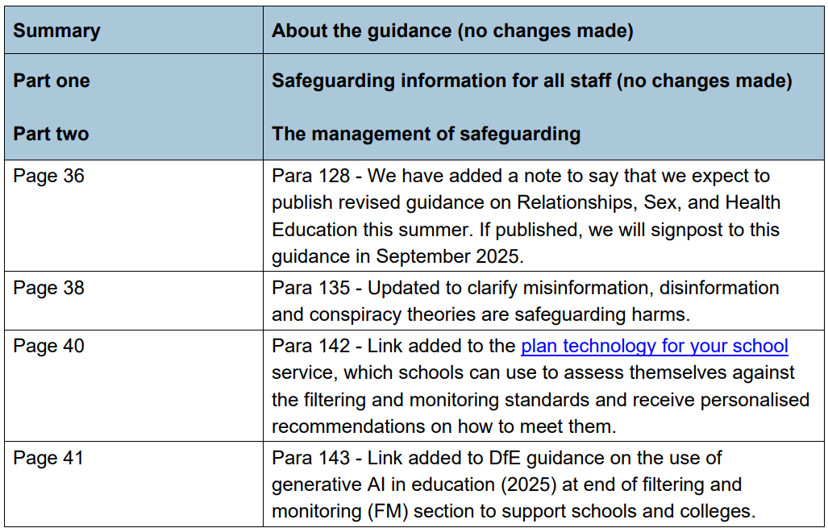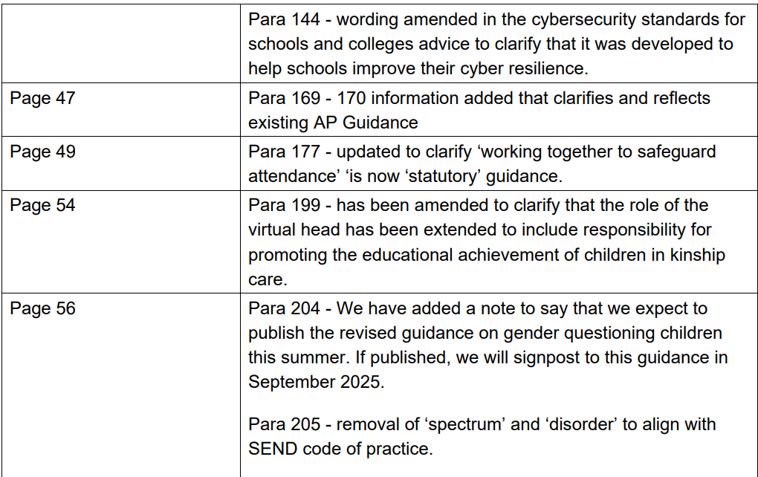

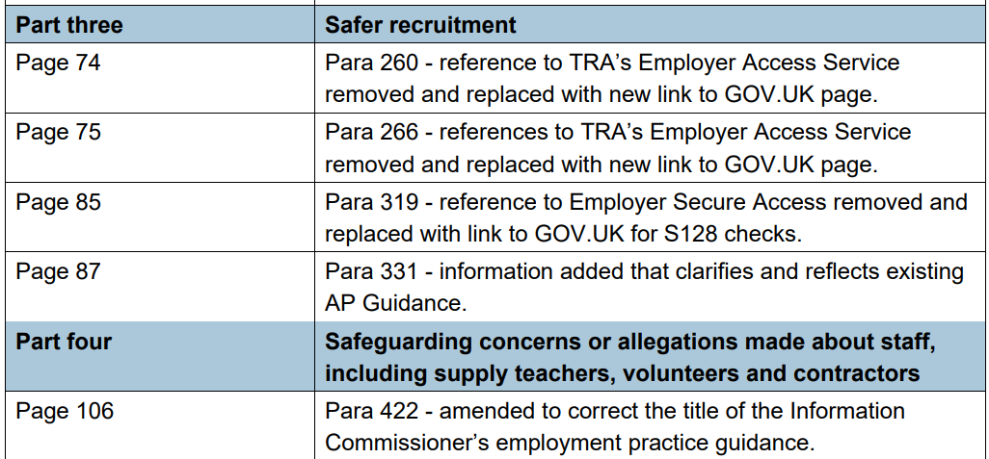

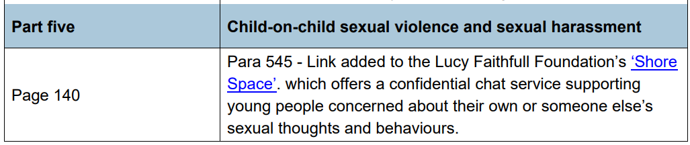 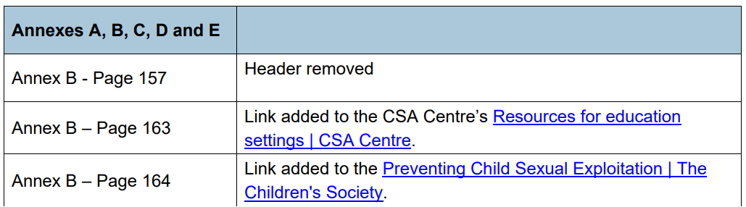
Appendix C: Useful Contacts


Cambridgeshire Local Safeguarding Partnership Board

Cambridgeshire and Peterborough Safeguarding Partnership Board

Key Information for WPS

Woodston Primary School | Name | Telephone contact | Email
Designated Safeguarding Lead | Nikki Lamond  Trevor Goakes | 01733 562784 | Nikki.lamond@woodstonprimary.org.uk  Trevor.goakes@woodstonprimary.org.uk
Deputy DSL | Steph Gilder | 01733 562784 | Steph.gilder@woodstonprimary.org.uk
Deputy DSL | Emma Champion | 01733 562784 | Emma.champion@woodstonprimary.org.uk
Deputy DSL | Sharon Davey | 01733 562784 | Sharon.davey@woodstonprimary.org.uk
Safeguarding Local Governing Committee member |  | 01733 562784
Single Point of Contact (SPOC) (Prevent lead) | Steph Gilder | 01733 562784 | Steph.gilder@woodstonprimary.org.uk
Online Safety Lead | Hannah Banister | 01733 562784 | Hannah.banister@woodstonprimary.org.uk
Domestic Abuse Lead | Steph Gilder | 01733 562784 | Steph.gilder@woodstonprimary.org.uk
The following members of staff have undertaken Safer Recruitment training | Nikki Lamond | 01733 562784 | Nikki.lamond@woodstonprimary.org.uk
 | Trevor Goakes | 01733 562784 | Trevor.goakes@woodstonprimary.org.uk
 | Lucinda Robinson | 01733 562784 | Lucinda.robsinson@woodstonprimary.org.uk

